**Introduction**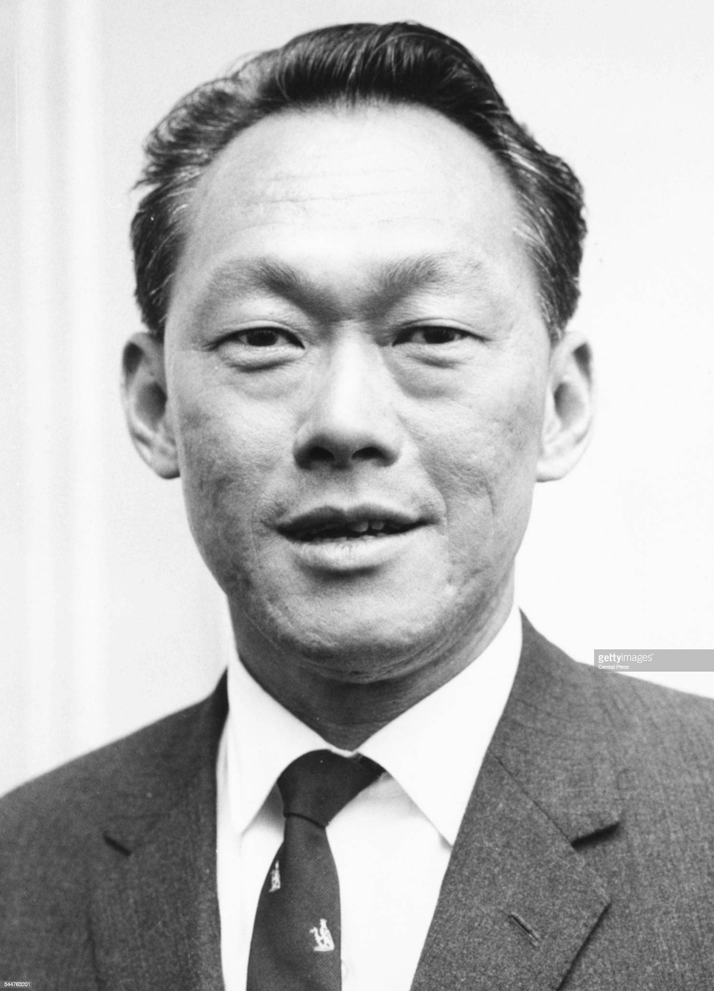

Hiya, this is a pretty basic guide on how I colourise portraits in the TNO style. I’ll be using a good quality source, a picture of [Lee Kuan Yew](https://media.gettyimages.com/photos/portrait-of-lee-kuan-yew-prime-minister-of-singapore-november-1976-picture-id544763201?s=2048x2048&w=6) as seen on the left. I use paint.net to colourise portraits, which can be downloaded for free from their website here: [(https://www.getpaint.net/download.html)](https://www.getpaint.net/download.html))

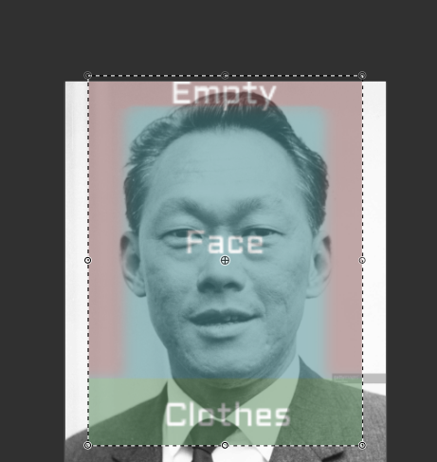

**Framing**

Typically I frame my portraits using a guide as seen [here](https://cdn.discordapp.com/attachments/645456775931232256/820629654754820096/unknown.png).

On the right you can see how I used low opacity on another layer to get a gist of how the framing should be. It is encouraged but not necessary while framing, to rotate the photo’s angle so that the subject’s eyes are looking straight. Once satisfied, crop the image to the selection.  
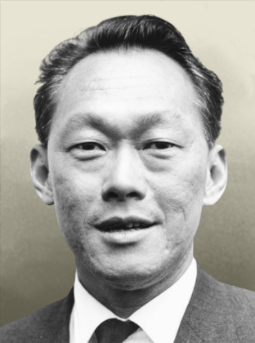

**Background Removal**

Before removing the background make sure to resize the portrait to **312px by 420px**. I colourise my portraits on double the hoi4 portrait size so it's easier to colour the more detailed parts of the picture. Another reason is that remove.bg compresses the image if the size is too large so it’s best to keep it small. When resizing I use the **Fant** setting which gives the best quality compared to other settings.

Now select and copy the portrait, and ctrl+v it into the [remove.bg](https://www.remove.bg/upload) website. The website removes backgrounds pretty fast in comparison to manual background removal. Manual background removal can be better at times but personally I like doing my portraits as quickly as possible (~~because im lazy~~).

Now paste the portrait onto a new layer above the [hoi4 portrait background](https://cdn.discordapp.com/attachments/645456775931232256/915248573715738635/leader_blank.png). ([here’s it in double size](https://cdn.discordapp.com/attachments/645456775931232256/915248522608128070/unknown.png)) This is the one TNO uses, with the grayish tint at the bottom. Make sure to **black and white** the portrait before you colourise it.

**Colourising**

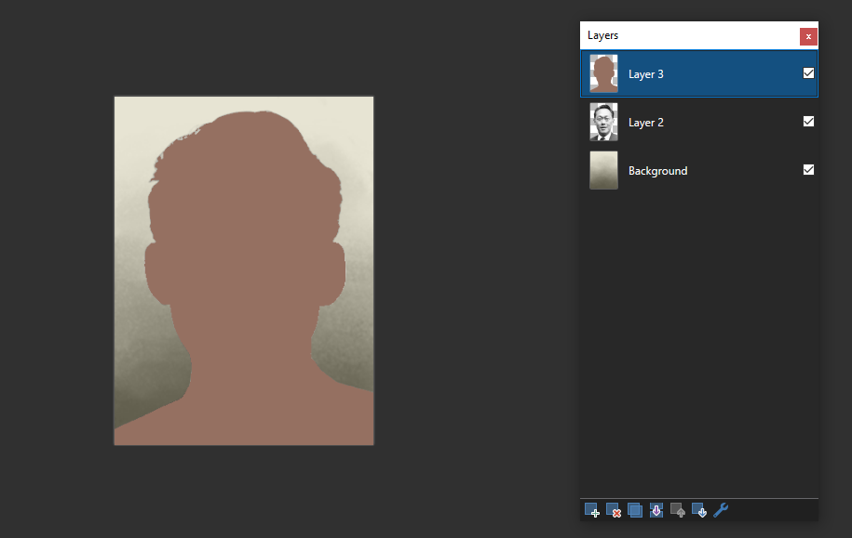Now for the meat of the tutorial, start by using the magic wand tool on 50% tolerance, global flood mode and selecting an empty area of the portrait, then inverse the selection using ctrl+i. Make a new layer and fill the selection with the skin colour I use, #957061 or the one more commonly used, #946F5F and set the layer to overlay. This way there will be no colour leakage on the portrait.

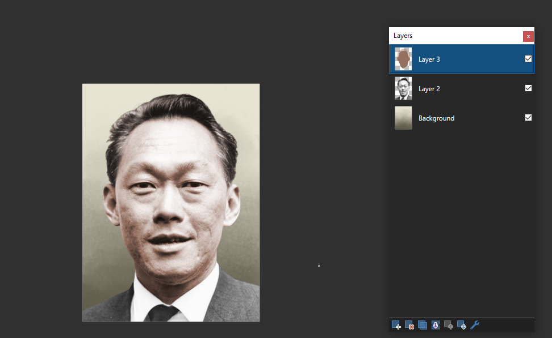

Now use the eraser tool on around **45% hardness** to erase the skin colour from the clothes. Then, I use the eraser tool on **0% hardness** and **125 or 150 opacity** to erase the hair area. I use 125 only to make the hair slightly brown, as 150 opacity makes it greyish to black. Here I used 150 as Lee Kuan Yew had black hair. Once that’s both done, apply **gauss blur of 4** on the skin colour layer. Lastly, use the eraser tool again on **0% hardness** but **125 opacity** to erase the colour from the eyes and teeth if it's present.

Now go to the original portrait layer, and make some adjustments so that the portrait does not look too bright or overexposed. Generally just play around with the brightness and contrast settings until it looks pretty decent. Don’t worry too much about perfecting it, it can always be adjusted later before the portrait is finished.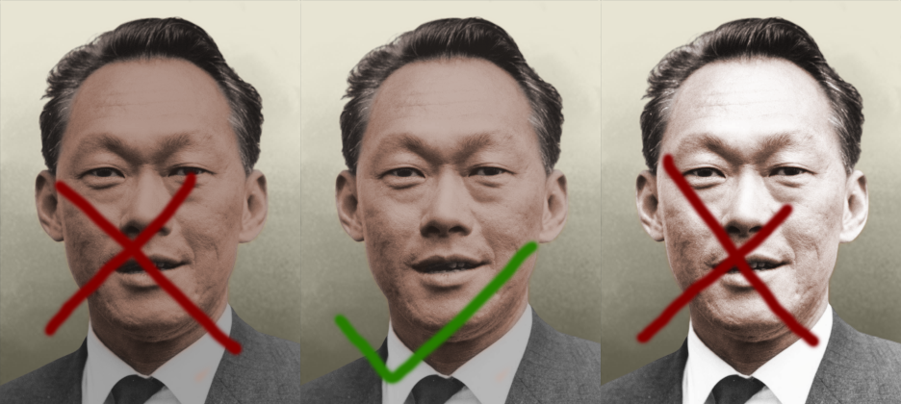

Edit - if portrait is super pale (base image overtly white and the pasty skin color doesn’t show up, try -22 Brightness -16 Contrast, once or twice until looks ‘right’

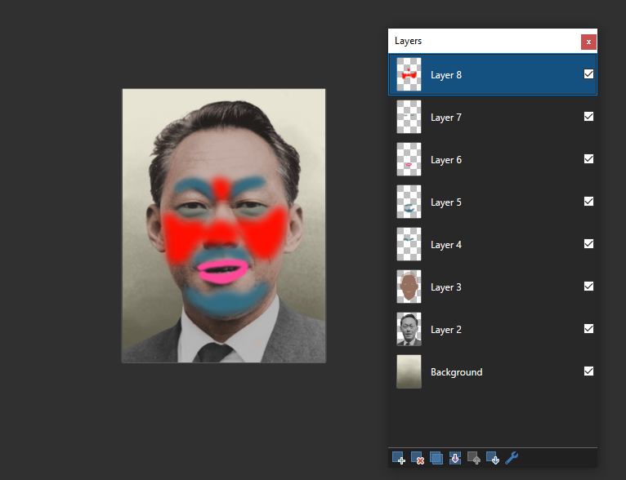Now I’m going to make Lee Kuan Yew look like a clown by adding some colour zones. I use a **0% hardness** brush while colourising so that the zones don’t have very solid borders (yes i colourise on separate layers cry about it). Hex colours for them:

**Eyebrows** (unconventional method of colourising them but it works, works for facial hair like moustaches too): #v, gauss 8 **twice**, 70-90 opacity on overlay  
**5 o’clock shadow**: #326C82, gauss 8 twice**,** 45-55 opacity on overlay

Lips: #FF4998, **no gauss**, 12 opacity on overlay  
**Under eyes**: #4A6F69, gauss 8 twice**,** 50-100 opacity on **difference blending mode**

**Under eyes** (alternative option if you don’t like the previous, do not do both at the same time): #FF0F00, gauss 8 twice, 15 opacity on overlay  
**Cheeks and nose**: #FF0F00, gauss 4 twice, 10-15 opacity on overlay

For eye colour, I usually use a light blue or a light brown on about 30-50 opacity, feel free to adjust it to be a bit more or less if its better, as I just eyeball them most of the time.

For suits I typically use brown or blue for the blazer and #94785F for white shirts. Tie colour again can be anything. Other clothing just eyeball them, I don’t really have a set colour for it either. Always keep the clothes colourised as everything has colour to it.

Here’s the [pdn file](https://cdn.discordapp.com/attachments/645456775931232256/913096714775326720/kuanyew.pdn) for it after colourising (i adjusted the brightness and contrast slightly after)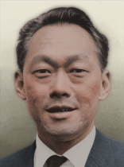

**Final Steps**

Resize the portrait to **156px by 210px**. Now merge the layers one by one onto the original portrait layer until it's just the hoi4 background and the portrait layer left. Duplicate the portrait layer and add **gauss 5** to the bottom layer. Now merge all layers and the portrait is now complete -->  
  
please clap  
(source restoration guide soon???)

GOLD - 97856D

BROWN UNIFORM - 513A2B

CSA UNIFORM - 585F65

GLASSES - (normal layer) 65 OPACITY - GAUS 8

Wemacht green - 6A6963